Advanced Battery Recycling
Abstract
The exponential growth of electric vehicles (EVs), consumer electronics, and renewable energy storage has accelerated demand for lithium-ion batteries (LIBs). Recycling end-of-life batteries is critical to reduce dependence on scarce raw materials, mitigate environmental hazards, and support circular economy principles. Traditional recycling methods—pyrometallurgy and hydrometallurgy—dominate current practice but face limitations in energy intensity, CO₂ emissions, and chemical waste. Emerging solutions such as direct cathode regeneration, biohydrometallurgy, photocatalytic metallurgy, and electrochemical recovery offer promising pathways to align recycling with the UN Sustainable Development Goals (SDGs). This paper provides a detailed review of existing processes, their limitations, and new industry solutions, with emphasis on India’s policy context.
1. Introduction
Global annual demand for batteries was ~933 GWh in 2021 and is projected to reach 5,100 GWh by 2030. India alone is expected to require ~600 GWh of advanced chemistry cells by 2030, driven by EV adoption and renewable energy integration. Recycling is essential to:
- Reduce dependence on imports of lithium, cobalt, and nickel.
- Prevent environmental hazards from unsafe disposal.
- Support circular economy and resource efficiency.
India’s draft Battery Waste Management Rules (2020) and the ACC PLI scheme highlight the government’s intent to build a domestic recycling ecosystem. However, technological and regulatory challenges remain.
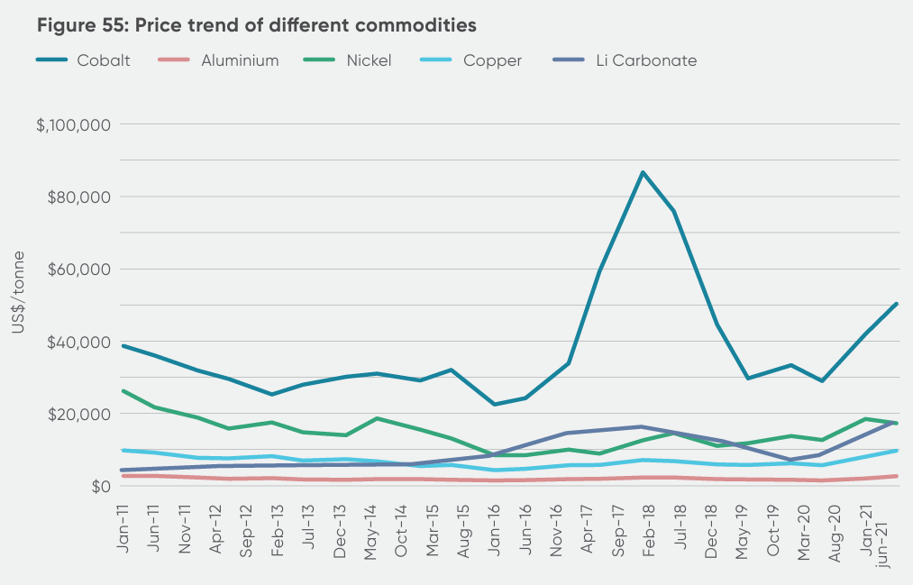
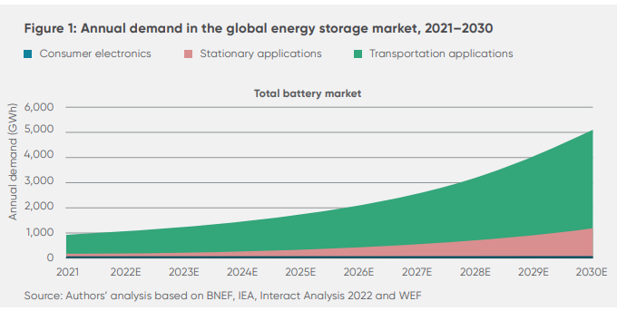
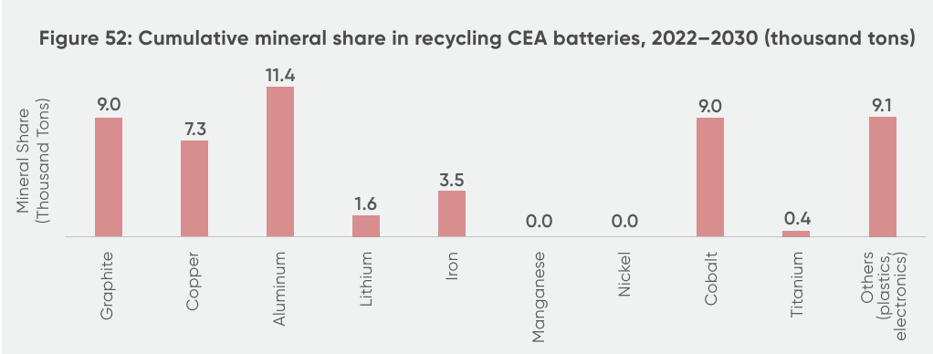
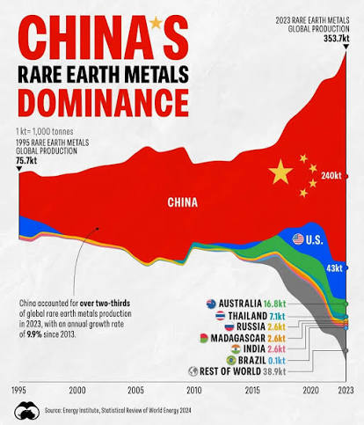

2. Recycling Processes
2.1 Pyrometallurgy
- Process: Smelting at >1000°C to recover cobalt, nickel, and copper.
- Advantages: Mature technology, scalable.
- Limitations:
  - High CO₂ emissions.
  - Lithium and aluminum lost in slag.
  - Toxic gases (SOx, NOx, HF) require treatment.
- Industrial Example: Umicore (Belgium) uses pyrometallurgy as a first step before hydrometallurgy.
- 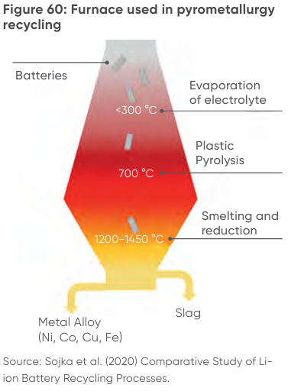
2.2 Hydrometallurgy
- Process: Acid leaching (H₂SO₄, HCl), solvent extraction, precipitation.
- Advantages: High recovery efficiency (>90% for Li, Co, Ni).
- Limitations:
  - Large volumes of wastewater.
  - Expensive reagents.
  - Multi-step complexity.
- Industrial Example: GEM (China) and Attero (India) use hydrometallurgy extensively.
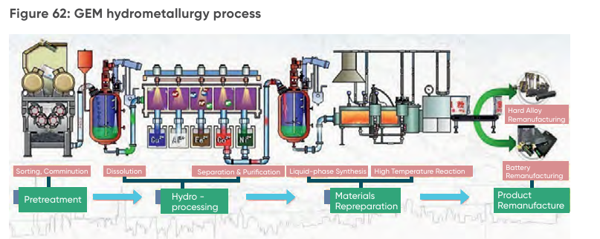
2.3 Mechanical Processing
- Process: Shredding, crushing, and separation into “black mass.”
- Advantages: Simple, scalable.
- Limitations:
  - Limited recovery efficiency.
  - Fire/explosion risks if batteries are not discharged.
  - Dust hazards.
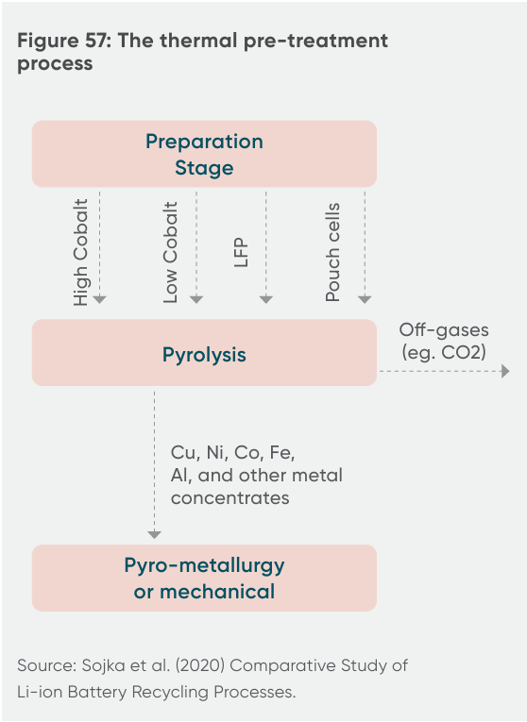
2.4 Pre-treatment
- Process: Thermal or mechanical preparation before chemical recovery.
- Advantages: Improves efficiency of downstream processes.
- Limitations:
  - Releases harmful gases (fluorine compounds).
  - Adds cost and complexity.
3. Limitations and SDG Mapping
Process | Limitation | SDG Impact
Pyrometallurgy | High CO₂ emissions, toxic slag | SDG 13 (Climate Action), SDG 12 (Responsible Consumption)
Hydrometallurgy | Chemical hazards, wastewater | SDG 6 (Clean Water), SDG 3 (Health & Well-being)
Mechanical Processing | Limited recovery, dust hazards | SDG 3 (Health), SDG 9 (Innovation)
Pre-treatment | Harmful emissions, cost | SDG 15 (Life on Land), SDG 12
Direct Recycling | Still experimental | SDG 9 (Industry, Innovation)
4. Emerging Industry Solutions
4.1 Direct Cathode Regeneration
- Concept: Restores spent cathodes (NMC, LFP) directly without breaking down into individual metals.
- Advantages: Lower energy use, reduced chemical waste.
- Challenges: Requires precise chemistry control.
- Reference: Lu et al. (2026, RSC).
4.2 Biohydrometallurgy
- Concept: Uses microorganisms or bio-acids to leach metals.
- Advantages: Environmentally friendly, avoids strong acids.
- Challenges: Slow kinetics, scalability.
- Reference: Yadav et al. (2026, Springer).
4.3 Photocatalytic Metallurgy
- Concept: Light-driven catalysts extract metals, potentially powered by solar.
- Advantages: Reduces chemical consumption, integrates with renewable energy.
- Challenges: Experimental, requires advanced catalyst design.
- Reference: ScienceDirect (2026).
4.4 Electrochemical Recovery
- Concept: Electrochemical cells selectively recover lithium and cobalt.
- Advantages: High purity recovery, renewable integration.
- Challenges: Requires precise process control.
- Reference: Zhang et al. (2025, Elsevier).
4.5 Biomass-Assisted Processing
- Concept: Uses organic acids from agricultural waste for leaching.
- Advantages: Links recycling with bioeconomy.
- Challenges: Limited industrial adoption.
- Reference: Chen et al. (2025, Nature Sustainability).
5. Policy and Regulatory Context
- India: Draft Battery Waste Management Rules (2020), ACC PLI scheme, Extended Producer Responsibility (EPR).
- Global: EU Battery Directive (2023), US DOE recycling initiatives, China’s GEM-led hydrometallurgy.
- Challenges:
  - Informal recycling markets in India.
  - Lack of strict enforcement.
  - Need for incentives (deposit-refund systems, green taxes).
6. Conclusion
Battery recycling is essential for sustainable energy transitions. Traditional methods (pyro/hydro) are effective but environmentally costly. Emerging solutions—direct regeneration, biohydrometallurgy, photocatalytic metallurgy, electrochemical recovery, and biomass-assisted processing—offer promising pathways to align recycling with SDGs. Future research should focus on:
- Scaling direct regeneration.
- Integrating renewable energy into recycling plants.
- Developing hybrid recycling approaches.
- Strengthening policy enforcement.
References
- Lu, X. et al. (2026). Evolution of lithium-ion battery recycling: state-of-the-art processes, emerging technologies, and future prospects. Royal Society of Chemistry.
- Yadav, R. et al. (2026). Process Optimization and Lithium Recovery in Lithium-Ion Battery Recycling. Springer.
- ScienceDirect (2026). Green recycling strategies for lithium-ion battery cathodes.
- Zhang, Y. et al. (2025). Electrochemical approaches for sustainable battery recycling. Elsevier.
- Chen, L. et al. (2025). Biomass-derived solvents for sustainable battery recycling. Nature Sustainability.
- NITI Aayog & UK Government (2022). Advanced Chemistry Cell Battery Reuse and Recycling Market in India.

